Oriented Objects Programming

Trần Ngọc Minh

20235608

Lab 03: Basic Object-Oriented Techniques

1. Working with method overloading:
   1. Overloading by differing types of parameter:

* 1. Overloading by differing the number of parameters

1. **Passing parameters**

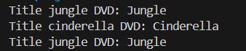

**Modified Source Code**

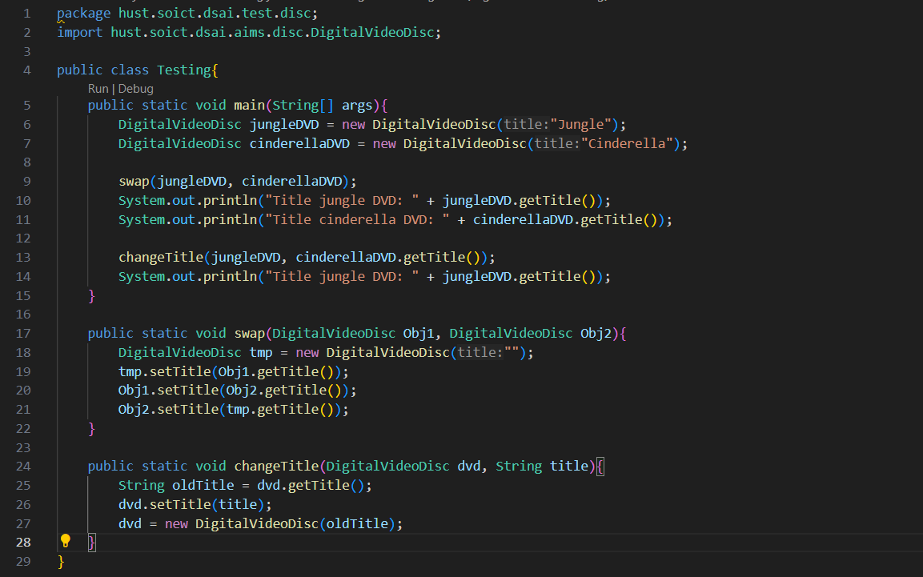

**Question:**

1. After the call of **swap(jungleDVD, cinderellaDVD)** why does the title of these two objects still remain?

Answer: When the swap function is invoked, it generates new references for the two objects, jungleDVD and cinderellaDVD, which we can call o1 and o2. As a result, any modifications made to o1 and o2 do not impact the original objects. Consequently, the titles of jungleDVD and cinderellaDVD remain unchanged after the swap function executes.

1. **After the call of changeTitle(jungleDVD, cinderellaDVD.getTitle()) why is the title of the JungleDVD changed?**

**Answer: When the function is called, it creates a new reference named dvd that points to the jungleDVD object. Therefore, any changes made to the title through the setTitle method using the dvd reference will directly affect the jungleDVD object. This is because both dvd and jungleDVD refer to the same underlying object in memory. So, updating the title via dvd will also update it for jungleDVD.**

1. **Class Member & Insane:**

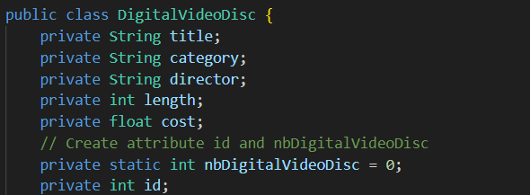

1. **Cart Class**

* Writing method to print items in cart

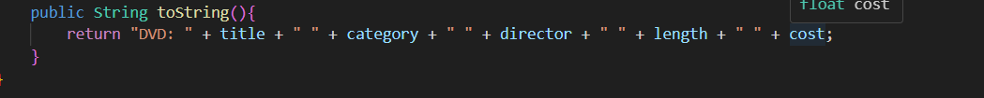

* Writing method to searching:

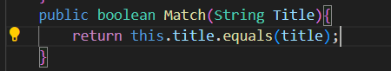

1. Store Class

1. **Reorganize projects**

1. **String, StringBuilder and StringBuffer**

1. Class Diagram

1. Use Case Diagram

